Southern Ontario Behavioural Decision Research Conference

SOBDR 2016

Program

May 6, 2016



Greetings Everyone!

SOBDR 2016 is ready to go and the day is full of fascinating research

This document should include all the information you need, but please email [sobdr2016@ivey.ca](mailto:sobdr2016@ivey.ca) if you need anything else.

If you haven’t registered yet please do so at: http://www.ivey.uwo.ca/faculty/research/sobdr-2016-registration/. (To enable us to plan the food order.)

Thanks for joining us, and helping to make the day a success.

Amos, June, Neil and Romel

Amos Nadler, Assistant Professor, Finance  
June Cotte, Scott & Melissa Beattie Professor in Marketing & Faculty Director of Research  
Neil Bendle, Assistant Professor of Marketing & David G. Burgoyne Faculty Fellow  
Romel Mostafa, Assistant Professor, Business, Economics and Public Policy

SOBDR 2016 sponsored by  
Ivey’s Research Centre for Building Sustainable Value

<http://www.ivey.uwo.ca/news/events/2016/5/sobdr-2016/>

Program

|  |  |  |
| --- | --- | --- |
| Time | Activity | Location |
| 9.00-9.45 | Continental Breakfast | Brock Pavilion |
| 9.45-10.00 | Introduction, June Cotte, Faculty Director of Research, Scott & Melissa Beattie Professor in Marketing | Auditorium |
| 10.00-10.30 | Nicole Robitaille (Queen’s) Nudging to Increase Organ Donor Registrations | Auditorium |
| 10.30-11.00 | Xin (Shane) Wang, (Ivey) Reconsidering the Endowment Effect: A Neuro-Processing Perspective | Auditorium |
| 11.00-11.15 | Coffee Break | Brock Pavilion |
| 11.15-12.30 | Keynote speaker --- Joe Arvai (University of Michigan) | Auditorium |
| 12.30-2.00 | Lunch and Posters | Brock Pavilion |
| 2.00-2.30 | Joseph Thomas Paniculangara (Ryerson) Curvilinear Effects of Social Distance on Prosocial Behaviour - a Dual Process Explanation | Auditorium |
| 2.30-3.00 | Ian Burt (Niagara University) An Understanding of the Differences between Internal and External Auditors in Obtaining Information about Internal Control Weaknesses | Auditorium |
| 3.00-3.15 | Coffee Break | Brock Pavilion |
| 3.15-3.45 | Supriya Syal (BE Works) Increasing enrolment in eStatements via email messaging: A field study | Auditorium |
| 3.45-4.15 | Tripat Gill (Wilfrid Laurier University) Will Self-Driving Cars Make us Less Moral? | Auditorium |
| 4.15-4.30 | Conclusion: Tima Bansal, Executive Director, Network for Business Sustainability, Canada Research Chair, Ivey Business School | Auditorium |
| 4.30-5.30 | Reception | Faculty Lounge |

Poster Session

|  |  |  |
| --- | --- | --- |
|  | Posters | title |
| 1 | Franki Kung, Justin Brienza, Danielle Balan, Cecilia Allan, Maria Bizev, Douglas Brown and Abigail Scholer (Waterloo) | Perceptions of Self-Control and Dehumanization: Robotizing the Highs and Animalizing the Lows |
| 2 | Joanna Minji Cho (York), Zhaleh Semnani-Azad (Clarkson), Alin Coman (Princeton), Wendi Adair (Waterloo), Katia Sycara (Carnegie Mellon), Michael Lewis (Pittsburgh) | Reasoning Frame Congruency and Negotiator Perception: Finding Flexibility amidst Sacred Values through an Observer Methodology |
| 3 | Geoffrey Hill (Waterloo) | Exploring price systems as emergently designed information technology: a heuristic approach for externalities with climate change applications |
| 4 | Deborah Kozdras (South Florida) | Using Model-Eliciting Activities to Help K-5 Students Make Informed Decisions About Sustainability Issues |
| 5 | Duncan Koerber & Nick Zabara | Preventing Damage: The Psychology of Crisis Communication Buffers in Organized Sports |
| 6 | Jinuk Oh (Guelph) | Authentic Leadership and Turnover Intention: Does Firm Size Matter? |
| 7 | Rochelle Evans, Lindie Liang, Winny Shen, Doug Brown (Waterloo) | Exploring the motives behind abusive supervision: An inductive approach |
| 8 | Jared Valdron (Waterloo), Aaron Schat (McMaster) | Explicit versus Implicit Monetary Attitudes in the Prediction of Workplace Decisions |
| 9 | Anna Iraheta Russo, Nita Chhinzer (Guelph) | Off Target: An Evidence-based Approach to Improving Coop Work-term Assessment Validity |
| 10 | Rebecca Elskamp (Guelph) | Scale Effects in Auctions with Multi-Unit Demand |
| 11 | Tianshu Zhu, John Paul Minda (Western) | “The Depletion of Self-Regulatory Resources Reduces Performance on Some Subsequent Tasks but not on All Tasks” |
| 12 | Monica Soliman, Johanna Peetz (Carelton) | Big Money: The Effect of Money Size on Value Perceptions and Saving Motivation |
| 13 | Navio Kwok, Sam Hanig, Douglas Brown (Waterloo) | Does self-control look like leadership? The impact of self-control perceptions on leadership inferences. |
| 14 | Alexander Walker (Waterloo) | Intuitive Confidence in a Sports Betting Domain |
| 15 | Gordon Pennycook (Waterloo) | Bullshit Detection |
| 16 | Kun Huo (Ivey), Khim Kelly, Alan Webb (Waterloo) | The effect of causal model representation on managerial decision making in a changing environment |
| 17 | Matthew Maxwell-Smith, Tiffany White (Illinois at Urbana-Champaign) | A case for “Trickle-up”? The Implications of Workforce Livelihood and Social Dominance Ideologies for Brand Attitudes |

Map: Western University Campus

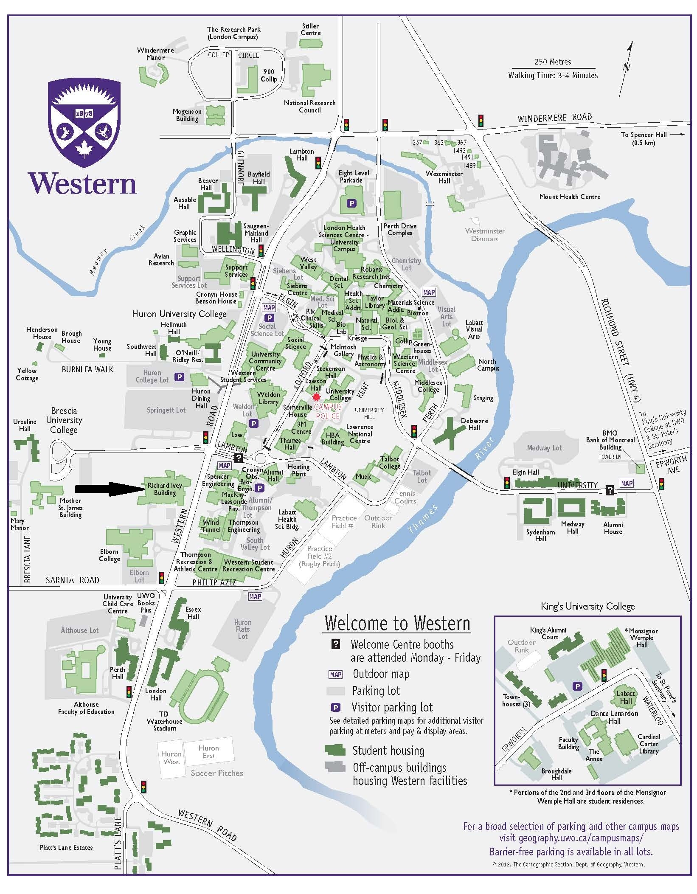

Directions

To the Ivey Business School and Western University

**From the East (Toronto or Kingston):**

* Follow Hwy 401 to exit 186 for Wellington Road toward London/Centre-ville/Downtown
* Turn right onto Wellington Road S (heading north)
* Turn left onto Commissioners Rd E (heading west)
* Turn right onto Wharncliffe Rd S ON-4 N (heading north)
* Continue onto Western Rd (Wharncliffe Rd turns into Western Rd at Oxford St)
* The New Ivey building will be on the left hand side, 1255 Western Rd
* See below for Details of parking

**From the West (Michigan):**

* I-94 E becomes Provincial Route 402 East (43.1 miles).
* Merge onto Hickory Drive / CR-39 via Exit 69 (2.1 miles).
* Turn slight right onto Provincial Route 22 / CR-22 / Egremont Drive. Continue to follow
* Provincial Route 22 (14.2 miles). The name changes to Fanshawe Park Road.
* Turn right onto Wonderland Rd (heading south)
* Turn left onto Sarnia Rd (heading east)
* Turn left onto Western Rd (heading north)
* The New Ivey Building will be on the left hand side, 1255 Western Rd
* See below for Details of parking

**From the South East (Hamilton and Niagara):**

* Follow Highway 403 to Highway 401 Exit West.
* Turn right onto Wellington Road S (heading north)
* Turn left onto Commissioners Rd E (heading west)
* Turn right onto Wharncliffe Rd S?ON-4 N (heading north)
* Continue onto Western Rd (Wharncliffe Rd turns into Western Rd at Oxford St)
* The New Ivey building will be on the left hand side, 1255 Western Rd
* See below for Details of parking

Parking

* General parking is available at Springett lot (entry from the traffic light at Huron University College). This lot is immediately over Brescia Road from the Ivey Building.

The gate to this lot will be open from 8.45-10.00am, you can just enter and park for free.

* A small number of spaces at the Ivey lot are available for those with mobility concerns. These must be reserved in advance. Please contact Kathryn Noble ([knoble@ivey.uwo.ca](mailto:knoble@ivey.uwo.ca)) by April 29th at the latest.
* If you come late and the Springett Lot gate has been closed you will need to find your own parking. (There are numerous spots around campus). The Alumni/Thompson (off the roundabout on Lambton immediately across Western Road) is a good choice and will cost $7.

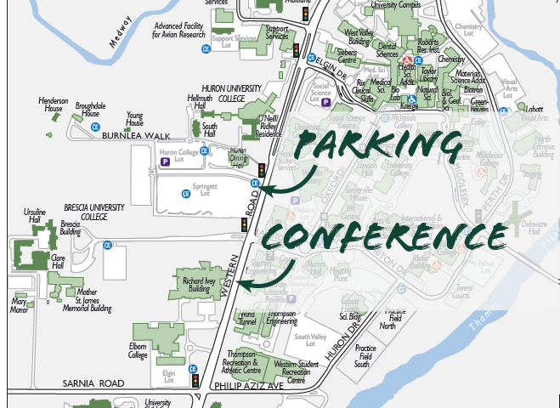

Dinner Afterwards

There is no conference dinner but dome of you may be looking for some ideas on places to eat before you go home. Here are a few suggestions:

## Informal

The Wave (Campus): 2nd Floor, UCC Building, University of Western Ontario, London http://westernusc.ca/wave/

Beertown (North of university) 109 Fanshawe Park Road, London http://www.beertown.ca/

## Up-Market

Abruzzi (Downtown) 119 King Street London http://abruzzi.ca/#italian-inspired-cuisine

The Only (Downtown) 172 King Street, London, <http://www.theonlyonking.ca/>

Hotels

If you plan to stay over in London we often suggest:

Station Park Hotel, [242 Pall Mall Street, London, ON N6A 5P6](http://www.stationparkhotel.com/contact-us/)

<http://www.stationparkhotel.com/>

This is in the centre of London so close to many places for dinner.

Ivey Spencer Leadership Centre, 551 Windermere Road, London, Ontario N5X 2T1, CAN

<http://www.iveyspencerleadershipcentre.com/>

This is just north of the university